**Exercises XML files**

**Exercise 1**

For this exercise you will use the XML file *plants.xml.*

1. Write a program that makes the following overview of the plants.

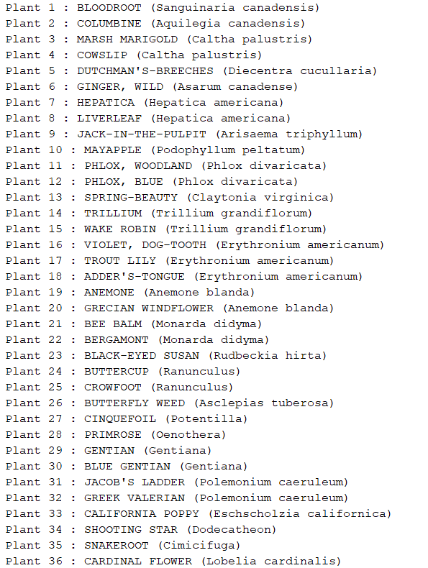

1. 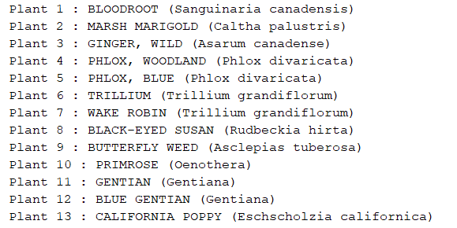Adjust your program so that you only print the plants that are best in the sun.

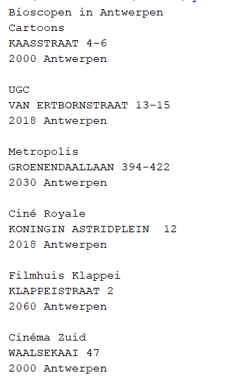**Exercise 2**

XML files are often distributed by open data initiatives. For this exercise you use the file *cinemas.xml*. This file has been distributed as open data by the City of Antwerp (so the information is in Dutch).

*Processing and combining such open data sources and converting this data into information suitable for analysis is an important component for students interested in Business Intelligence.*

The file *cinemas.xml* is not nicely aligned. It's up to you to interpret the file so you can print a list of the Antwerp cinemas. (the first 6 can be found in the screenshot)

**Exercise 3**

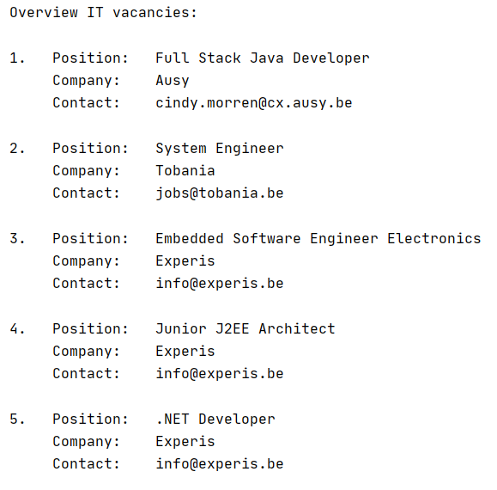

For this exercise you will use the XML-file *jobs.xml*.

Write a program that makes the following overview.

Note: only the vacancies for IT jobs are mentioned!

**Exercise 4**

For this exercise you use the XML-file *drugs.xml*.

Write a program to make some changes to this file.

* You remove the element *pharmaceutical_forms* everywhere (including all child elements).
* You make sure the name of the drug is in capital letters.

You save the custom XML document under the name *drugs_changed.xml*

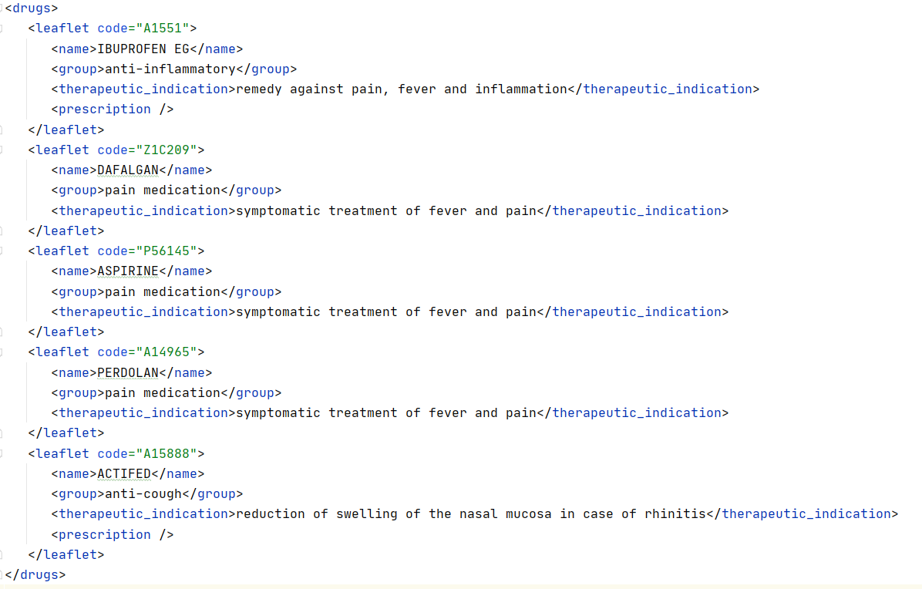

**Exercise 5**

For this exercise you use the file *songs.txt*. Write a program that converts this txt file to an XML file songs.xml.

